

**Lab 1 Report**

Lab 1 Topic: Daraz App Review

Course Title: Software Engineering

Course Code: CSE412

**Section: 03**

**Submitted to:**

Nishat Tasnim Niloy

Lecturer

Department of Computer Science & Engineering,

East West University

**Prepared by:**

| **Group Member Name** |
| --- |
| Golam Kibria (2021-3-60-215) |
| B. M. Shahria Alam (2021-3-60-016) |
| A.B.M. Ilman Farabi (2021-3-60-111) |

Date of submission: 29/10/2024

**Screenshot of Homepage (App Store)**

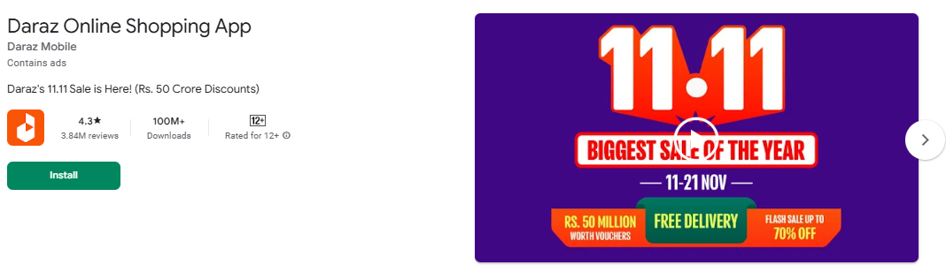

**1. Features (Functionality)**

**1. Product Categories and Search**

Daraz provides a broad range of categories, from electronics, fashion, and home appliances to groceries and more. The app’s search functionality allows users to quickly find specific products or brands.

**2. Flash Sales & Daily Deals**

The app has flash sales, daily deals, and limited-time discounts on various products, making it easier for users to find high-value deals.

**3. DarazMall**

This is a dedicated section for authentic and premium brands. DarazMall assures high-quality products with a return and exchange policy.

**4. Voucher Discounts & Coins Collection**

Users can collect vouchers and use Daraz coins to receive discounts on their purchases, adding a gamified element to shopping.

**5. Secure Payment Options**

The app offers various secure payment methods, including credit/debit cards, mobile wallets, and cash on delivery, catering to different user preferences.

**6. In-app Chat and Support**

Customers can chat with sellers directly for inquiries and with Daraz customer support for assistance with orders, returns, and refunds.

**7. Order Tracking**

Users can track their orders in real-time, giving visibility into the shipping process from the warehouse to delivery.

**8. Personalized Recommendations**

Based on browsing and purchase history, Daraz provides personalized product recommendations to enhance the shopping experience.

**9. Easy Returns and Refunds**

Daraz offers hassle-free returns and refunds for eligible products, ensuring customer satisfaction with after-sales support.

**10. Unique Feature**

**(Daraz Live)** This live-streaming feature allows sellers to showcase products in real-time, with viewers able to purchase directly from the live stream, adding an interactive element to shopping.

**2. Non- functional attributes**

* **Performance**
* The system should be able to support millions simultaneous users.
* Generally fast on reliable connections. Slower during high-traffic events (sales/festivals).
* **Security**
* The system shall provide password protected access to web pages that are to be viewed only by employees.
* Transaction data must be transmitted in encrypted form.
* **Usability**
* A sales agent should be able to use the system in his job after 7 days of training.
* A user who already knows what product he is interested in should be able to locate and view that page in 10 seconds.
* The number of web pages navigated to access product information from the top page should not exceed 3.
* **Reliability**
* The system shall be completely operational at least 95% of the time.
* Down time after a failure shall not exceed 2 hours.
* **Scalability**
* Daraz Bangladesh is expanding its product offerings and seller base while investing in logistics and warehousing to enhance order fulfillment and accommodate growing customer demand.
* The platform leverages advanced technology for efficient operations and employs effective marketing strategies, diverse payment options, and engaging features to attract and retain a growing user base.

**3. Client Satisfaction**

1. **Feedback**

**1.⭐⭐⭐⭐⭐** I've had a mixed experience with the Daraz app. On the plus side, it offers a wide range of products across various categories and often features attractive deals and discounts. The user interface is generally intuitive, and the search function helps in finding items quickly. However, there are areas that need improvement. Delivery times can be inconsistent, and there have been instances of items arriving later than expected or not matching the description.

**2.⭐⭐**The app is good, I've seen no bugs so far. But they need to update the search engine. Whenever I search something up, about 95% of the results are irrelevant to my search, so it becomes very hard to find the desired product, and this was the biggest problem with using this app. They need to optimize the search engine as soon as possible.

**3.⭐** Worst update of the history. It's downgrade. (Also it was forced update. Without the update, the app wasn't opening.) Searching for something specific doesn't mean anything now. You'll see all the random items together even if you search for something specific. And Wishlist is খিচুরি now. Thanks for stopping me from buying stuff.

1. **Size:** 35MB
2. **Version:** 9.5.0 (Requires Android 5.0 and up)
3. **Rating:** 4.3⭐ (3.84M reviews)
4. **Download** 100M+
5. **Competitors:** Pickaboo, Chaldal**,** Shopify, Amazon.